- The signs are that the UK housing market is slowly starting to pick up again, following a temporary soft patch immediately after the change in stamp duty thresholds at the end of March. The Bank of England reported that mortgage lending rose strongly in June, and the increase in mortgage approvals suggest this upward momentum will continue.
- When the Bank of England meets next week, we expect Bank Rate to be lowered by 25bps to 4%. The Monetary Policy Committee will continue to point to the need to carry on reducing interest rates "carefully and gradually".
In what has been a quiet week in the UK, the focus has been on the housing market, which looks to be gradually picking up following the change in stamp duty thresholds at the end of March. Demand has been supported by falls in quoted mortgage rates as financial markets continue to expect further interest rate cuts. We expect the Bank of England's Monetary Policy Committee to lower Bank Rate to 4% at its meeting next week.
Activity in the housing market has been volatile this year as the temporary increase in stamp duty thresholds expired at the end of March. Transactions and mortgage lending ramped up sharply towards the end of Q1 as home movers rushed to complete house purchases before the tax changes came into place. However, with some purchases having been brought forward, transactions and mortgage lending fell sharpy in April. But early signs suggest that this drop off was relatively short-lived. The BoE's latest Money & Credit data released this week showed that after a partial rebound in May, net mortgage lending increased further, rising to £5.3bn in June from £2.2bn a month earlier (Chart 1).
Chart 1: Mortgage lending and approvals continued to recovery after April's slump
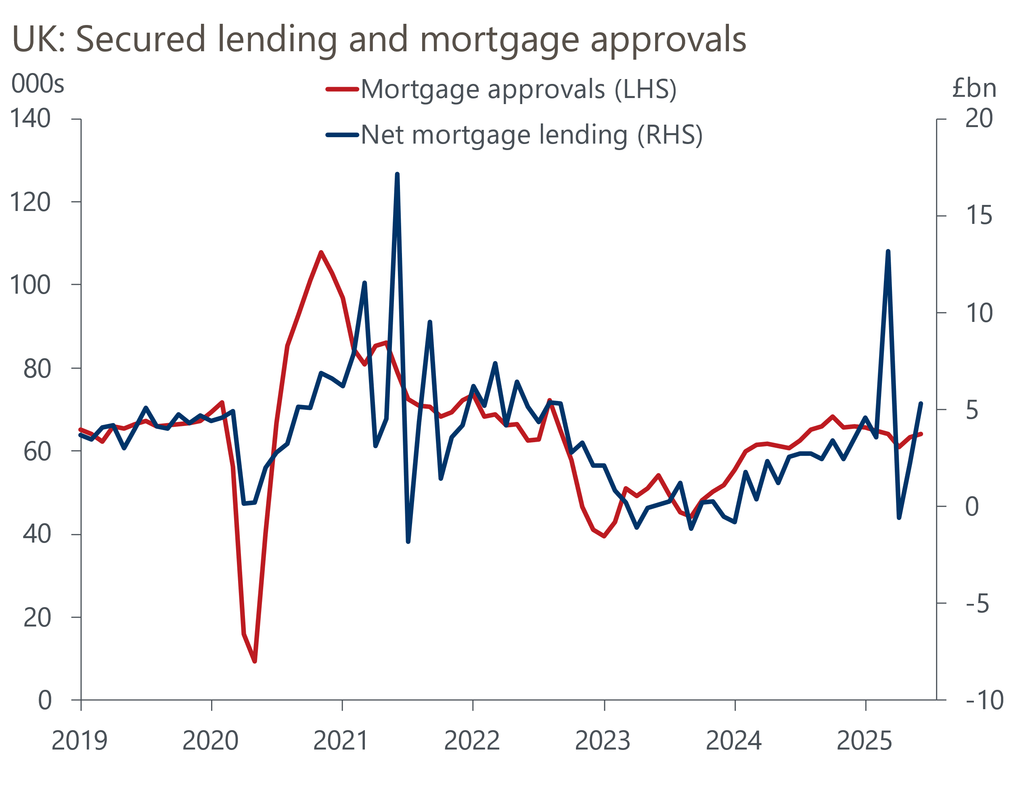
Source: Haver Analytics

The recovery in housing market activity looks set to continue with mortgage demand having increased further in June. Mortgage approvals, which tend to lead transactions and the disbursements of funds by a few months, increased to 64,167, from 63,288 in May. This means the number of approvals for new home purchases was broadly comparable to the level seen before the stamp duty change.
Mortgage demand continues to be supported by lower quoted mortgage rates. At the start of Q2, financial markets increased their expectations for interest rate cuts, and lenders responded in turn by lowering mortgages rates. The BoE's latest data showed that the typical quoted interest rate on a 2-year fixed-rate 75% LTV mortgage rose 13bps to 4.32% in June. However, this is still significantly below the interest rate offered on mortgage deals in Q1.
In line with market expectations, we expect the BoE to deliver another 25bp cut at its meeting next week. This would see Bank Rate lowered to 4%. But with the interest rate decision likely offering little surprise, the focus will be on the MPC's guidance on the future path of interest rates. Given the levelling off in the BoE's preferred measure of underlying services inflation – a key indicator of inflationary pressures – and revisions to HMRC's employee payroll data that make the deterioration in the jobs market look less severe, we think that the committee will judge that a "gradual and careful" approach to loosening policy remains the appropriate course of action. This guidance will probably mask the level of disagreement amongst rate setters, and we think that it's likely that two committee members will vote in favour of no change, while two more may vote favour of a larger 50bp rate cut.
The MPC will also update their projections in next week's Monetary Policy Report. We think that the changes will likely reinforce the committee's guidance on its "gradual and careful" approach to cutting rates. In its May projections, the MPC published a forecast where inflation fell back to just below the 2% target in a couple of years' time, based on a quarterly pace of cuts through this year. With market pricing little changed from three months ago, we expect the August projections to again show inflation settling around 2% in the medium term (Chart 2).
Chart 2: Financial markets still expect a gradual reduction in Bank Rate across the second half of the year
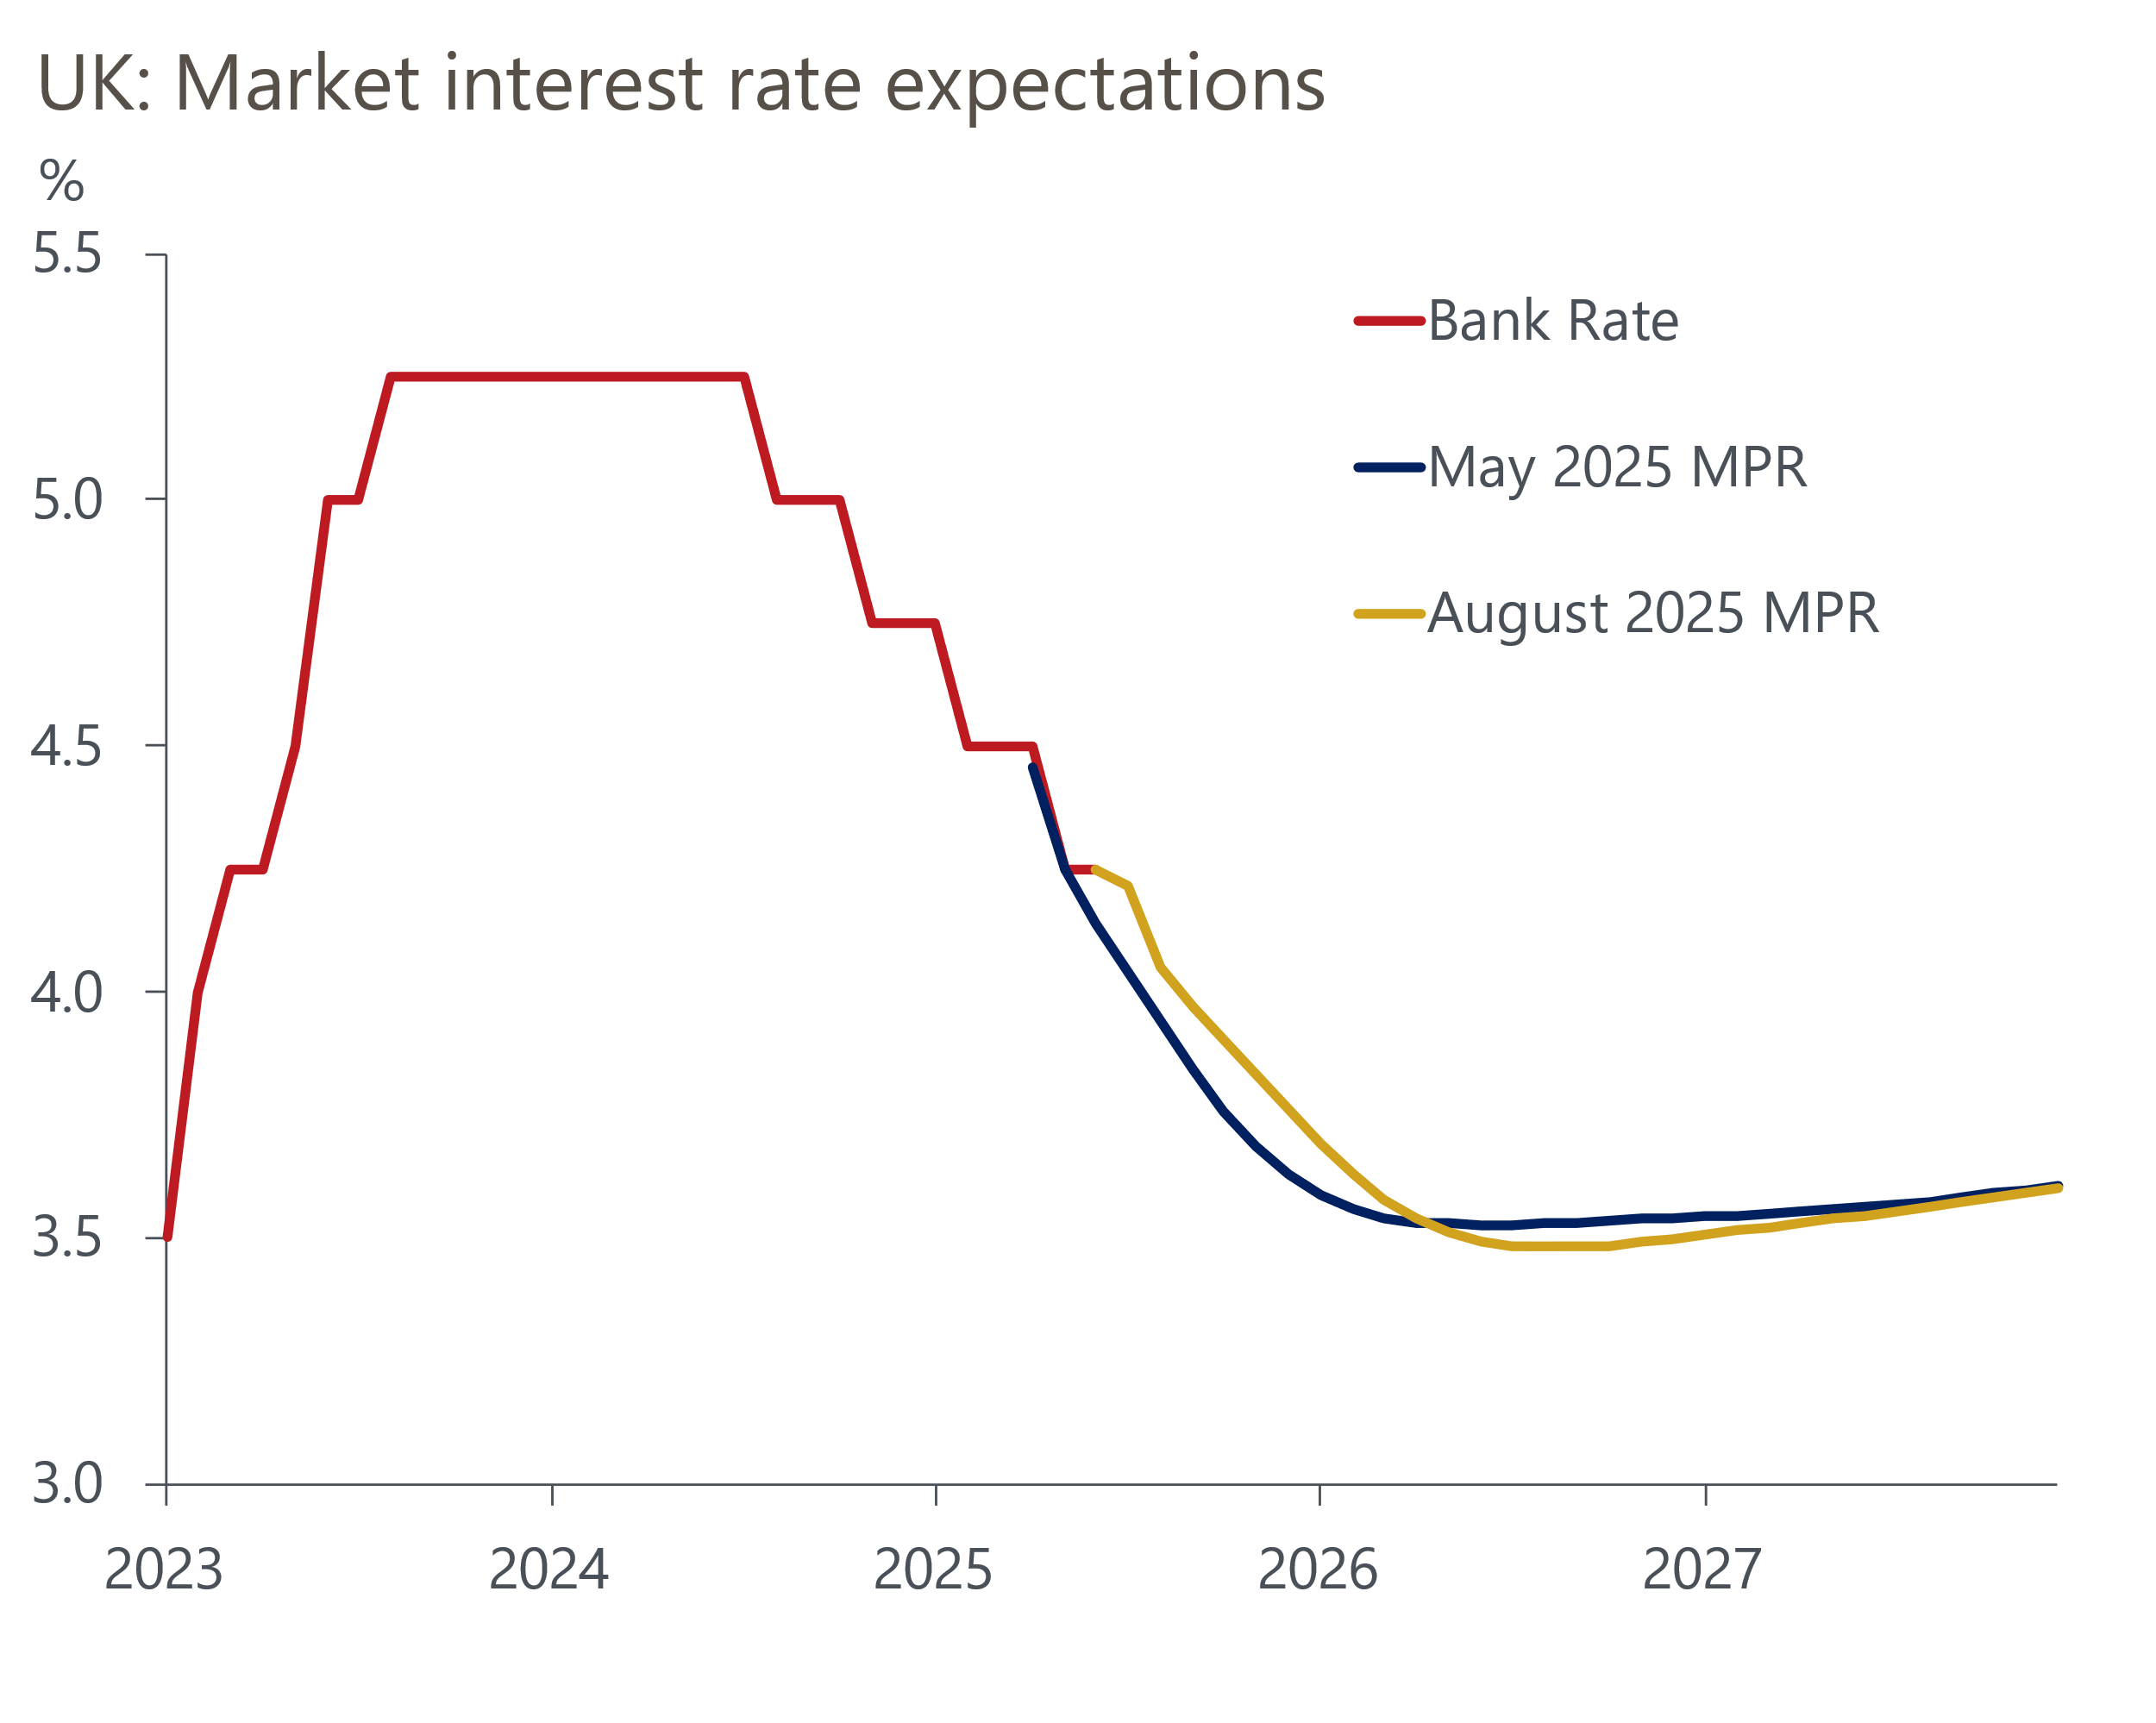
Source: Haver Analytics
This week also saw the release of July's S&P Global manufacturing survey. Respondents to the survey reported that output continued to fall in the sector, and goods providers reduced headcount further. At the same time, there was a relatively benign picture for core goods inflation, with firms reporting that input cost pressures had levelled off and that this had been reflected in prices paid by customers. These signals support our view that the Bank of England will continue to reduce Bank Rate beyond its August meeting.

The week ahead
The major event next week is the Bank of England's interest rate decision. We expect the Monetary Policy Committee to lower Bank Rate by 25bps to 4%. But we think there's likely to be some disagreement between committee members, with two favouring no change and two voting for a larger 50bp cut. The MPC is likely to maintain its guidance that it intends to continue to gradually cut interest rates. Its updated forecasts are likely to reinforce this message.
July's S&P Global flash composite and services PMI slipped to 51.0 and 51.2, from 52.0 and 52.8 respectively, with businesses continuing to report sluggish growth, reduced headcounts and sustained cost pressures. There is no clear pattern of revisions, so we think the final composite and services PMIs will be similar to the flash estimates.
Table 1: Week ahead calendar
Date | Events | Period | Measure | Unit | Previous | Forecast
Aug 5 | S&P Global composite | Jul | PMI | % bal | 51.0 | 51.0
Aug 5 | S&P Global services | Jul | PMI | % bal | 51.2 | 51.2
Aug 7 | Halifax house prices | Jul | m/m | % | 0.0 | 0.3
Aug 7 | Halifax house prices | Jul | y/y | % | 2.5 | 2.0
Aug 7 | BoE Bank Rate decision | Aug | Bank Rate | % | 4.25 | 4.00
Source: Oxford Economics

Key forecasts
Table 2: UK forecast overview
(Annual percentage changes unless specified)
 | 2023 | 2024 | 2025 | 2026 | 2027 | 2028
GDP | 0.4 | 1.1 | 1.1 | 0.9 | 1.3 | 1.8
Private consumption | 0.5 | 0.6 | 1.1 | 1.1 | 1.2 | 1.8
Fixed investment | 0.3 | 1.5 | 1.8 | 0.8 | 1.6 | 2.0
Government consumption | 1.6 | 3.0 | 1.5 | 1.7 | 1.6 | 1.7
Exports of goods and services | -0.4 | -1.2 | 1.2 | 0.1 | 1.2 | 1.4
Imports of goods and services | -1.2 | 2.7 | 3.4 | -1.3 | 1.1 | 1.4
Industrial Production | -0.8 | -1.2 | 0.0 | -0.5 | 0.7 | 1.2
Consumer prices | 7.3 | 2.5 | 3.4 | 2.7 | 2.4 | 2.1
Unemployment rate (%) | 4.1 | 4.3 | 4.7 | 5.0 | 4.9 | 4.5
Current a/c balance (% of GDP) | -3.5 | -2.7 | -3.3 | -2.9 | -2.7 | -2.7
Government balance (% of GDP) | 5.2 | 5.1 | 4.3 | 3.6 | 3.0 | 2.7
Central bank policy rate (%, EOP) | 5.25 | 4.75 | 3.75 | 3.00 | 2.50 | 2.50
10yr govt. bond yield (%, EOP) | 3.54 | 4.57 | 4.55 | 4.04 | 3.47 | 3.35
Exchange rate (US$ per £, EOP) | 1.27 | 1.25 | 1.36 | 1.36 | 1.36 | 1.36
Exchange rate (euro per £, EOP) | 1.15 | 1.21 | 1.17 | 1.17 | 1.17 | 1.17
Source: Oxford Economics
Table 3: Quarterly forecasts for the UK
 | 2025 |  |  |  | 2026
 | Q1 | Q2 | Q3 | Q4 | Q1 | Q2 | Q3 | Q4
GDP (% year) | 1.3 | 0.9 | 1.1 | 1.2 | 0.7 | 0.8 | 0.9 | 1.0
CPI inflation (% year) | 2.8 | 3.5 | 3.8 | 3.5 | 3.3 | 2.5 | 2.5 | 2.5
Bank Rate (%, EOP) | 4.50 | 4.25 | 4.00 | 3.75 | 3.50 | 3.25 | 3.25 | 3.00
10yr gilt yield (%, EOP) | 4.70 | 4.48 | 4.60 | 4.55 | 4.48 | 4.35 | 4.20 | 4.04
US$ per £ (EOP) | 1.29 | 1.37 | 1.36 | 1.36 | 1.36 | 1.36 | 1.36 | 1.36
Euro per £ (EOP) | 1.20 | 1.17 | 1.17 | 1.17 | 1.17 | 1.17 | 1.17 | 1.17
Source: Oxford Economics

Latest Country Economic Forecast:
July 17, 2025

Recent publications

Data Insights
Manufacturing PMI pointed to a slightly shallower decline in July
Mortgage activity continued to recover strongly in June
June rebound in retail sales hides a challenging backdrop
The PMIs started Q3 on a softer note
Tax rises are looking increasingly likely

Research Briefings
MPC Preview - The case for faster cuts has faded for now
Why interest rate cuts remain a blunt tool
BoE likely to slow QT to avoid adding to gilt market strains
How the sectoral mix of jobs is changing and what it means
MPC’s dovish hold boosts the chances of an August cut

Contacts

Oxford Economics' UK team
- Andrew Goodwin - Chief UK Economist - agoodwin@oxfordeconomics.com
- Edward Allenby - UK Economist - eallenby@oxfordeconomics.com

